**CODECAMP DAY-2**

**Program 1:**

**import** java.util.Scanner;

**public** **class** Marks {

**public** **static** **void** main(String[] args) {

String ename;

**int** digital,digital1,digital2;

**int** java,java1,java2;

**int** networking,networking1,networking2;

**int** digitalsum,digitalavg;

**int** javaavg,javasum;

**int** networksum,networkavg;

Scanner sc=**new** Scanner(System.***in***);

System.***out***.println("enter scholar1 name");

ename=sc.next();

System.***out***.println("enter the marks of digital logic");

digital=sc.nextInt();

System.***out***.println("enter marks of java");

java=sc.nextInt();

System.***out***.println("enter marks of networking");

networking=sc.nextInt();

System.***out***.println("enter Scholar 2 name:");

ename=sc.next();

System.***out***.println("enter marks of digital logic");

digital1=sc.nextInt();

System.***out***.println("enter marks of java");

java1=sc.nextInt();

System.***out***.println("enter marks of networking");

networking1=sc.nextInt();

System.***out***.println("enter Scholar 3 name:");

ename=sc.next();

System.***out***.println("enter marks of digital logic");

digital2=sc.nextInt();

System.***out***.println("enter marks of java");

java2=sc.nextInt();

System.***out***.println("enter marks of networking");

networking2=sc.nextInt();

digitalsum=digital+digital1+digital2;

digitalavg=digitalsum/3;

System.***out***.println("average of Digital-Logic of three scholars is:"+digitalavg);

javasum=java+java1+java2;

javaavg=javasum/3;

System.***out***.println("average of Java of three scholars is"+javaavg);

networksum=networking+networking1+networking2;

networkavg=networksum/3;

System.***out***.println("average marks in networking of three scholars is"+networkavg);

}

}

**Output :**

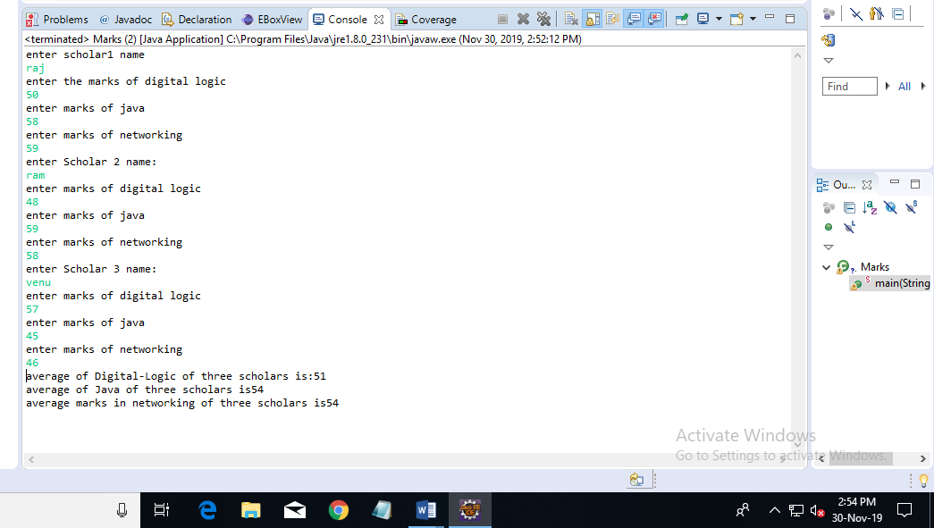

**Program 2:**

**import** java.util.Scanner;

**public** **class** CommonDistinct {

**public** **static** **void** main(String[] args)

{

**int** flag=0;

**int**[] array1=**new** **int**[5];

**int**[] array2=**new** **int**[5];

Scanner sc=**new** Scanner(System.***in***);

System.***out***.println("Enter First array elements");

**for**(**int** i=0; i<5; i++)

{

array1[i]=sc.nextInt();

}

System.***out***.println("Enter Second array elements");

**for**(**int** i=0; i<5;i++)

{

array2[i]=sc.nextInt();

}

//comparing elements in two arrays

**for**(**int** i=0;i<5;i++)

{

**for**(**int** j=0;j<5;j++)

{

**if**(array1[i]==array2[j])

{

System.***out***.println("common element is "+array1[i]);

i++;

flag=1;

}

}

}

**if** (flag==0) {

System.***out***.println("Distinct elements");

}

}

}

**Output:**

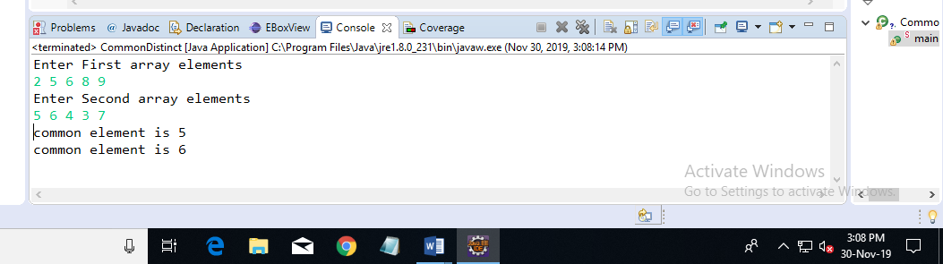

**Program 3:**

**import** java.util.Scanner;

**public** **class** Password {

**public** **static** **final** **int** ***PASSWORD_LENGTH*** = 10;

**public** **static** **void** main(String[] args) {

Scanner input = **new** Scanner(System.***in***);

System.***out***.print(

"1. A password must have at least ten characters.\n" +

"2. A password consists of only letters and digits.\n" +

"3. A password must contain at least two digits \n" +

"Input a password (You are agreeing to the above Terms and Conditions.): ");

String s = input.nextLine();

**if** (*is_Valid_Password*(s)) {

System.***out***.println("Password is valid: " + s);

} **else** {

System.***out***.println("Not a valid password: " + s);

}

}

**public** **static** **boolean** is_Valid_Password(String password) {

**if** (password.length() < ***PASSWORD_LENGTH***) **return** **false**;

**int** charCount = 0;

**int** numCount = 0;

**for** (**int** i = 0; i < password.length(); i++) {

**char** ch = password.charAt(i);

**if** (*is_Numeric*(ch)) numCount++;

**else** **if** (*is_Letter*(ch)) charCount++;

**else** **return** **false**;

}

**return** (charCount >= 2 && numCount >= 2);

}

**public** **static** **boolean** is_Letter(**char** ch) {

ch = Character.*toUpperCase*(ch);

**return** (ch >= 'A' && ch <= 'Z');

}

**public** **static** **boolean** is_Numeric(**char** ch) {

**return** (ch >= '0' && ch <= '9');

}

}

**OUTPUT:**

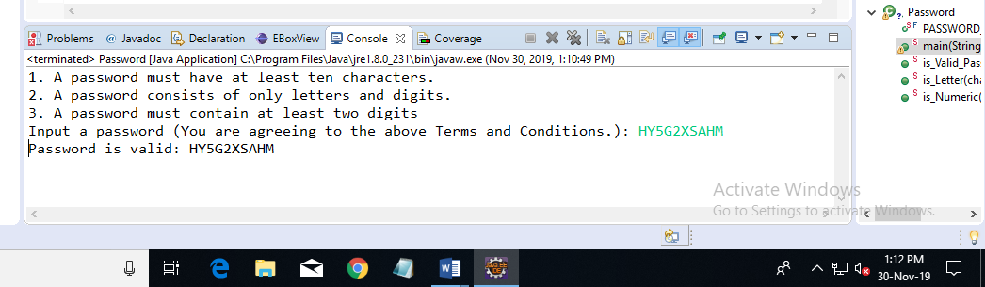

**Program 4:**

**import** java.util.Scanner;

**public** **class** Charcter

{

**public** **static** **void** main(String[] args)

{

Scanner sc=**new** Scanner(System.***in***);

System.***out***.println("Enter a string");

String string=sc.next();

**int** length=string.length();

**if**(length%2!=0)

{

**char** p= (**char**) string.codePointAt(length/2);

System.***out***.println("The middle character is "+p);

}

**else**

{

**char** p1= (**char**) string.codePointAt((length/2)-1);

**char** p2= (**char**) string.codePointAt(length/2);

System.***out***.println("The middle characters are "+p1+" "+p2);

}

}

}

**Output:**

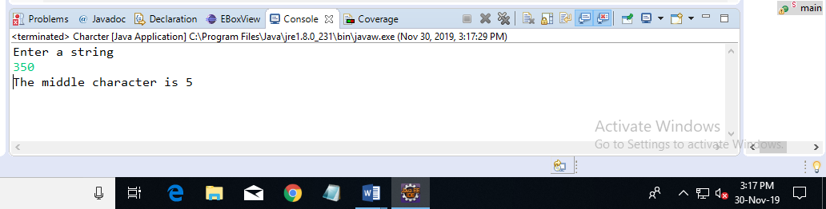

**Program 5:**

**import** java.util.Scanner;

**class** Palindrome

{

**public** **static** **void** main(String args[])

{

String string, reverse = "";

Scanner sc = **new** Scanner(System.***in***);

System.***out***.println("Enter a string:");

string = sc.nextLine();

**int** length = string.length();

**for** ( **int** i = length - 1; i >= 0; i-- )

reverse = reverse + string.charAt(i);

**if** (string.equals(reverse))

System.***out***.println(string+" is a palindrome");

**else**

System.***out***.println(string+" is not a palindrome");

}

}

**Output:**

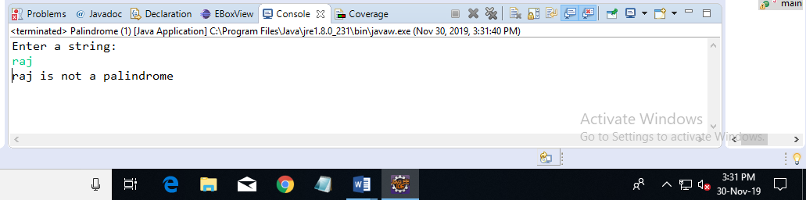

**Program 6:**

**import** java.util.Scanner;

**public** **class** Year {

**public** **static** **void** main(String args[])

{

**int** q,q1,q2,year,week, month, day;

Scanner sc = **new** Scanner(System.***in***);

System.***out***.print("Enter the number of days:");

q = sc.nextInt();

year = q / 365;

q1 = q % 365;

System.***out***.println("Number of years:"+year);

week=q/7;

month = q / 30;

System.***out***.println("Number of month:"+month);

q2=week&7;

day=q;

System.***out***.println("Number of days:"+day);

}

}

**Output:**

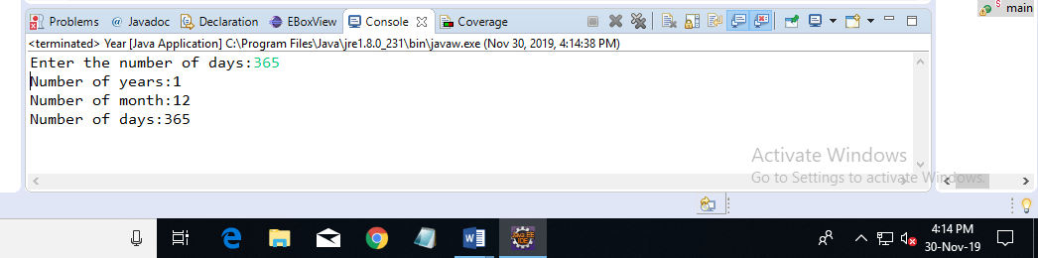

**Program 7:**

**import** java.text.DecimalFormat;

**import** java.util.Scanner;

**public** **class** GrossSalary {

**public** **static** **void** main(String args[]) {

Scanner sc =**new** Scanner(System.***in***);

**float** basicSal=0.00f;

**float** HRA=0.0f,DA=0.0f,GrossSal=0.0f;

System.***out***.println("enter employee basic salary");

basicSal=sc.nextFloat();

**if**(basicSal<1500) {

HRA= 0.1f*basicSal;

DA=0.05f*basicSal;

GrossSal= HRA+DA+basicSal;

System.***out***.println("Gross Salary:"+GrossSal);

}

**else** **if**(basicSal>=1500) {

HRA= 500;

DA=0.98f*basicSal;

GrossSal= HRA+DA+basicSal;

System.***out***.println("Gross Salary:"+GrossSal);

}

}

}

**Output:**

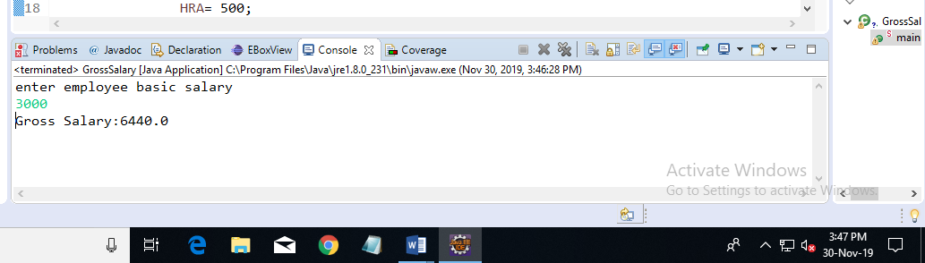

**Program 8:**

**import** java.util.Scanner;

**public** **class** Smallarray {

**static** Scanner *sc*= **new** Scanner(System.***in***);

**public** **static** **int** getSmallest(**int**[] k) {

**int** tem;

**for**(**int** i=0;i<10;i++)

{

**for**(**int** j=i+1;j<10;j++)

{

**if**(k[i]>k[j])

{

tem=k[i];

k[i]=k[j];

k[j]=tem;

}

}

}

**return** k[0];

}

**public** **static** **void** main(String[] args)

{

**int** k[]=**new** **int**[10];

System.***out***.println("Enter the numbers:");

**for**(**int** i=0;i<10;i++)

{

k[i]=*sc*.nextInt();

}

**int** smallestnumber=*getSmallest*(k);

System.***out***.println("Smallest number in array is:"+smallestnumber);

}

}

**Output:**

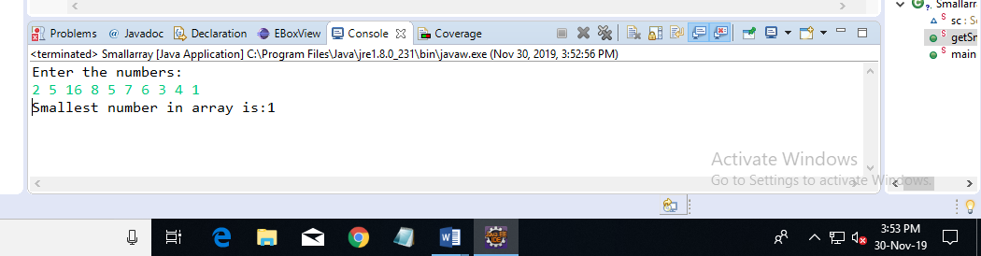

**Program 9:**

**import** java.util.Scanner;

**public** **class** ReverseString {

**public** **static** **void** main(String[] arg)

{

String reverse= "";

**int** len;

System.***out***.print("Enter a string : ");

Scanner sc=**new** Scanner(System.***in***);

String str=sc.nextLine();

len=str.length();

**for**(**int** i=str.length()-1;i>=0;i--) {

reverse=reverse+str.charAt(i);

}

System.***out***.println("Reverse of a String :");

System.***out***.println( reverse);

System.***out***.println("length of string="+len);

}

}

**Output:**

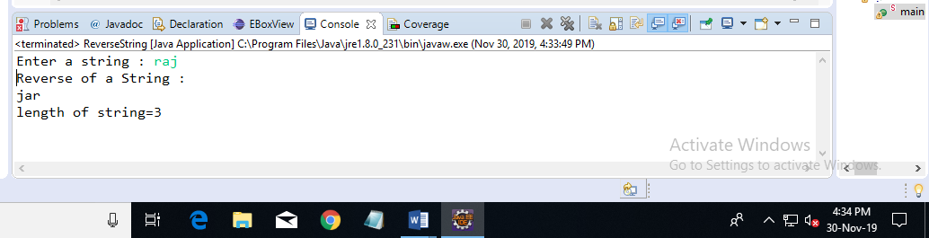

**Program 10:**

**public** **class** Maxvalue {

**public** **static** **void** main(String args[]){

**int** array[] = **new** **int**[]{9, 1, 5, 4, 8,10};

**int** Maxvalue = *getMaxvalue*(array);

System.***out***.println("Maxvalue = "+Maxvalue );

}

**public** **static** **int** getMaxvalue (**int**[] inputArray){

**int** MaxValue = inputArray[0];

**for**(**int** i=1;i < inputArray.length;i++){

**if**(inputArray[i] > MaxValue){

MaxValue = inputArray[i];

}

}

**return** MaxValue;

}

}

**Output:**

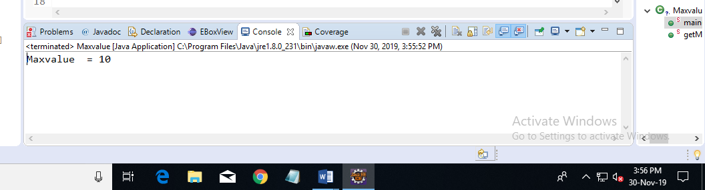

**Program 11:**

**import** java.util.Scanner;

**public** **class** Pattern {

**public** **static** **void** main(String[] args)

{

**int** i, space, rows, k=0;

Scanner scan = **new** Scanner(System.***in***);

System.***out***.print("Enter Number of Rows :");

rows = scan.nextInt();

**for**(i=1; i<=rows; i++)

{

**for**(space=1; space<=(rows-i); space++)

{

System.***out***.print(" ");

}

**while**(k != (2*i-1))

{

System.***out***.print("*");

k++;

}

k = 0;

System.***out***.println();

}

}

}

**Output:**

